FINANCE – INVESTMENT OPTIONS NAME ___________________
LEARNING OBJECTIVES | CHAPTER SUMMARY
After studying this chapter, students will be able to:
Obj. 1 | Explain why you should prepare for and establish an investment program. | Investment goals must be specific and measurable and should be classified as short term, intermediate, and long term. Before beginning an investment program, you must make sure your personal financial affairs are in order. This process begins with learning to live within your means and providing adequate insurance protection. The next step is the accumulation of an emergency fund equal to three to nine months’ living expenses. Then, and only then, is it time to save the money needed to establish an investment program.
Obj. 2 | Describe how safety, risk, income, growth, and liquidity affect your investment decisions. | Although each investor may have specific individual reasons for investing, all investors must consider the factors of safety, risk, income, growth, and liquidity. Especially important is the relationship between safety and risk. Basically, this concept can be summarized as follows: The potential return for any investment should be directly related to the risk the investor assumes. The risk factor can be broken down into five components: inflation risk, interest rate risk, business failure risk, market risk, and global investment risk.
Obj. 3 | Identify the major types of investment alternatives. | Investment alternatives include stocks, bonds, mutual funds, and real estate. More speculative investment alternatives include options, derivatives, commodities, precious metals, gemstones, and collectibles. Before choosing a specific investment, all potential investments should be evaluated on the basis of safety, risk, income, growth, and liquidity. You should also diversify your investments to lessen risk. With all of these factors in mind, the next step is to develop a specific, personal investment plan to help you accomplish your goals.
Obj. 4 | Recognize the role of the professional financial planner and your role in a personal investment program. | There are no hard and fast rules that define what a person must to in order to use the designation of Personal Financial Planner. In general, however, there are a number of reputable associations that regulate the use of regulated designations such as CFP (Certified Financial Planner), RFP (Registered Financial Planner), and FP (Financial Planner). These associations generally insist on formal training of some kind as well as a minimum of experience and commitment. Financial planners can help individuals achieve their investment goals, but choosing a qualified planner is your responsibility. It is your responsibility to evaluate and monitor the value of your investments and to keep accurate and current records.
Obj. 5 | Use the various sources of financial information that can reduce investment risks and increase investment return. | Since there is more information on investments than most investors can read and comprehend, investors must be selective in the type of information that they use for evaluation purposes. Sources of information include: the Internet, newspapers and news programs, business periodicals, government publications, corporate reports, statistical averages, and investor services.

CHAPTER 10 LECTURE OUTLINE
PREPARING FOR AN INVESTMENT PROGRAM
- The decision to start an investment program is an important first step to accomplishing your long-term financial goals.
Establishing Investment Goals
- To be useful, investment goals must be specific and measurable.
- Investment goals must be tailored to your particular financial needs.
- Investment goals must always be oriented toward the future.
Performing a Financial Checkup
- Before beginning an investment program, you must make sure your personal financial affairs are in order. To be successful, you must:
- Work to balance your budget.
- Obtain adequate insurance protection.
- Start an emergency fund equal to three to nine months’ living expenses.
- Have access to other sources of cash for emergency needs.
Getting the Money Needed to Start an Investment Program
- Once you have established your investment goals and completed your personal financial checkup, it’s time to start investing—assuming that you have enough money to finance your investments.
- As pointed out earlier in this chapter, no one can make you save money to finance your investment program. The following suggestions may help you obtain the money you need.
- You must pay yourself first.
- Take advantage of employer-sponsored retirement programs.
- You should participate in an elective savings program.
- You can also make a special savings effort one or two months each year.
- You should take advantage of gifts, inheritances, and windfalls.
The Value of Long-Term Investment Programs
- Many individuals never start an investment program because they only have a small sum of money. But even small sums of money grow over a long period of time.
- Exhibit 10-1 shows how much your investment would be worth at the end of selected time periods with different rates of return if you invested $2,000 each year.
FACTORS AFFECTING THE CHOICE OF INVESTMENTS
- Although each investor may have specific individual reasons for investing, there are a number of factors that all investors must consider.
Safety and Risk
- The safety and risk factors are two sides of the same coin. Safety in an investment means minimal risk of loss. On the other hand, risk in an investment means a measure of uncertainty about the outcome.
- A Speculative investment is a high-risk investment made in the hope of earning a relatively large profit in a short time
- Investments range from very safe to very risky. At one end of the investment spectrum are very safe investments that attract conservative investors. Investors pick such investments because they know there is very little chance that investments will become worthless.
- At the other end of the investment spectrum are very risky investments. Such investments offer the possibility of a larger dollar return, but if they are unsuccessful, the investor may lose most or all of the initial investment.

Risk Tolerance

- Risk tolerance is the amount of psychological pain you are willing to suffer from your investments. You could lose part or your entire principal, the purchasing power of your investment can decrease and you may not receive the returns you expected.
- In addition, the money you invested in securities, mutual funds, and other similar investments are not insured by the CDIC (Canadian Deposit Insurance Corporation).

Components of the Risk Factor
- The factor of risk associated with a specific investment does change from time to time. In fact, the overall risk factor can be broken down into the following five components.
- Inflation risk
- Interest rate risk
- Business failure risk
- Market risk
- Global Investment Risk
Investment Income
- Investors sometimes purchase certain investments because they want a predictable return or distribution of income from their investment.
- If income is a primary objective, most investors choose government bonds, corporate bonds, preferred stock, utility stocks, or selected common stocks. Other investments that provide income potential are mutual funds and real estate rental property.
- The more speculative investments, such as commodities, options, precious metals, gemstones, and collectibles, offer little, if any potential for regular income.
Investment Growth
- To investors, growth means that their investment will increase in value.
- Government bonds, corporate bonds, stocks, mutual funds, and real estate may offer growth possibilities.
- Precious metals, gemstones, and collectibles are more speculative investments and offer less predictable growth possibilities.
Investment Liquidity
- Liquidity is the ease with which an asset can be converted to cash without a substantial loss in dollar value.
AN OVERVIEW OF INVESTMENT ALTERNATIVES
- When establishing an investment program, investors should begin by gathering as much information as possible about investment alternatives.
- Once you have established your emergency fund and have some money in the bank, it’s time to consider other investment alternatives.
Stock or Equity Financing
- Equity capital is money that a business obtains from its owners.
- Investors should consider at least two factors before investing in stock. First, a corporation is not obligated to repay the money obtained from the sale of stock or to repurchase the stock at a later date. Second, a corporation is under no legal obligation to pay dividends.
- A dividend is a distribution of money, stocks, or other property that a corporation pays to shareholders.
- There are two types of stock—common and preferred.
Corporate and Government Bonds
- There are two types of bonds that an investor should consider. A corporate bond is a corporation’s written pledge that it will repay a specified amount of money with interest. A government bond is the written pledge of a government or a municipality that it will repay a specified sum of money with interest.
- The maturity dates for most bonds range between 1 and 30 years.
- Interest payments on bonds are made every six months.
Mutual Funds
- A mutual fund is an investment alternative available to individuals who pool their money to buy stocks, bonds, and other securities based on the selections of professional managers who work for an investment company.
- Professional management is an especially important factor. Another reason why investors choose mutual funds is because of diversification.
- The goals of one investor may differ from those of another investor. The managers of mutual funds realize this and tailor programs to meet individual needs and objectives.

Segregated Funds

- A segregated fund is an investment alternative in the form of an annuity that is similar to a mutual fund but that is less risky as it provides a certain degree of insurance to the investor. Once the annuity matures, the investor is entitled to 100 percent of the initial investment minus any withdrawals.
Real Estate
- As a rule, real estate increases in value and eventually sells for a profit, but there are no guarantees.
- Any investment has its disadvantages, and real estate is no exception. Like any other investment, real estate must be evaluated.
Other Investment Alternatives
- A speculative investment is a high-risk investment that is made in the hope of earning a relative large profit in a short time.
- Speculative investments include: call options, put options, derivatives, commodities, precious metals, gemstones, coins, stamps, and antiques and collectibles. More detailed information is provided in later chapters.
Summary of the Factors that Affect the Choice of Investments
- Earlier in this chapter, we examined how the factors of safety, risk, income, growth, and liquidity affect investments. Now it is possible to compare the different investment alternatives to those factors.
- Diversification is the process of spreading your assets among several types of investments to minimize risk.
A Personal Investment Plan
- To be successful, you must develop a plan and then implement it.
- The individual begins investment planning by establishing realistic goals.
- The next step is to perform a personal financial checkup.
- The steps required for an effective personal plan of action are presented in Exhibit 10-5. A completed financial plan for Salomé Mari illustrated in Exhibit 10-6.
The Role of a Financial Planner
- There is no such thing as a nationally designated financial planner in Canada. A number of organizations however allow special designations after certain criteria have been met.
- Financial planners may be divided into two categories; the first category consists of salaried planners who provide advice either free or for a nominal fee.
- The second category consists of commission planners who receive compensation from the sellers of the services and products that they sell.
Your Role in the Investment Process
- Evaluation of an investment should begin before purchasing an investment and after it is purchased.
- Good investors continually assess the value of their investments. Some basic elements of evaluation include:
1. Evaluate potential investments.
2. Monitor the value of your investment.
3. Keep accurate and current records.
Tax Considerations
- Generally, investment income is tax exempt, tax deferred, or taxable.
- With the exception of capital dividends, the dividends, interest, and profits you receive from your investments are subject to federal income tax.
- Dividends are taxed in a peculiar way that is designed to reflect that the corporation paying you a dividend has already paid taxes on its profits. The total of the amount you receive in eligible dividend is “grossed up” by 45 percent. You are then taxed at your marginal rate minus a dividend tax credit at the rate of 18.97 percent. Non-eligible dividends continue to be grossed up by 25 percent and are then taxed at your marginal rate minus a dividend tax credit at the rate of 13.33 percent.
- Interest income and rental income is taxed as ordinary income.
- You are taxed on 50 percent of all capital gains you receive. Capital losses can only be used to offset capital gains.


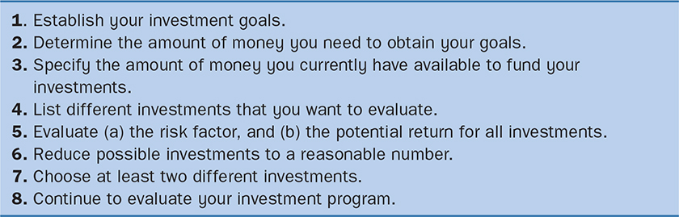
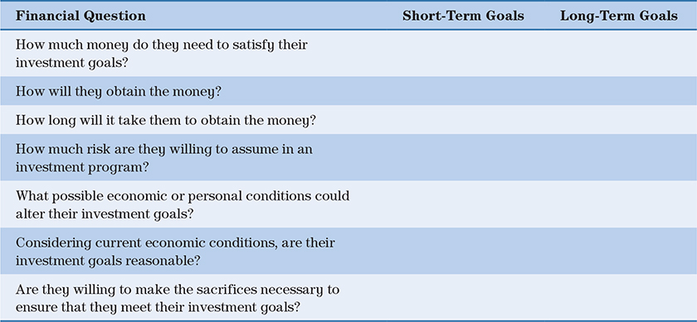
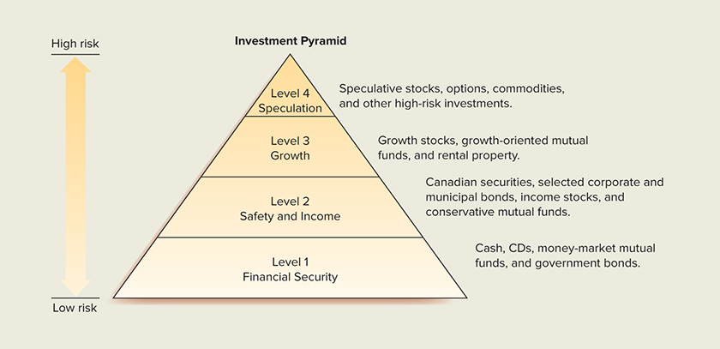

v